

**LA MENNAIS SCHOOLS ACADEMIC COMMITTEE**

**BEGINNING OF TERM II EXAMINATIONS**

**P.6 INTEGRATED SCIENCE**

*Time allowed: 2 Hours 15 minutes*

Name: ......................................................................................................................

School: ……………………………………..……….……Stream:……….……….

***SECTION A***

1. Why is a goat said to be a mammal?

_____________________________________________________________________________________________

2. Mention one animal that is kept at home for defense.

_____________________________________________________________________________________________

3. How do farmers benefit from having proper records about their farms?

_____________________________________________________________________________________________

_____________________________________________________________________________________________

4. Apart from alcohol, name any other liquid used in thermometers.

_____________________________________________________________________________________________

5. Name the smallest blood vessel.

_____________________________________________________________________________________________

6. Give one reason why farmers mulch their gardens.

_____________________________________________________________________________________________

_____________________________________________________________________________________________

7. Give one reason why some layers lay eggs with soft shells.

_____________________________________________________________________________________________

8. Identify any one practice done at home to reduce on the dangers of mosquitoes.

_____________________________________________________________________________________________

9. State one characteristic that enables some birds to fly.

_____________________________________________________________________________________________

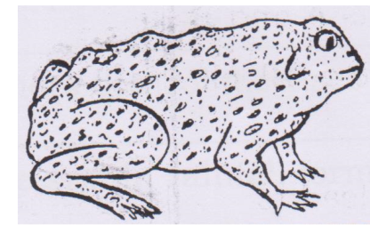

10. Apart from the lungs, what other part of the animal drawn above is used for respiration?

_____________________________________________________________________________________________

11. What do you understand by the term shearing as used in sheep rearing?

_____________________________________________________________________________________________

12. Write down one reason why some people drink alcohol.

_____________________________________________________________________________________________

13. Name the part of the skeleton which protects the heart.

_____________________________________________________________________________________________

14. Identify any one example of a constrictor found in the environment.

_____________________________________________________________________________________________

15. What name is given to the three small bones found in the middle ear?

_____________________________________________________________________________________________

16. One of the methods of soil formation is weathering of rocks, name any one factor that helps in the process of weathering.

_____________________________________________________________________________________________

_____________________________________________________________________________________________

17. Name the plant fibre used in industries to make clothes.

_____________________________________________________________________________________________

18. Write PIASCY in full.

_____________________________________________________________________________________________

_____________________________________________________________________________________________

19. Why is freezing referred to as a physical change?

_____________________________________________________________________________________________

_____________________________________________________________________________________________

20. In the space provided below, draw the beak of a bird classified under nectar suckers.

21. Name the organism that is used in the fermentation process.

_____________________________________________________________________________________________

22. Which element of PHC promotes oral health?

_____________________________________________________________________________________________

23. How can poultry farmers control diseases on their farms?

_____________________________________________________________________________________________

_____________________________________________________________________________________________

24. What is the use of the sun in rainfall formation?

__________________________________________________________________________________________________________________________________________________________________________________________

25. Besides a cockroach, mention any other example of an insect which undergoes an incomplete metamorphosis.

_____________________________________________________________________________________________

26. Soil erosion is the removal of top sol. How is it controlled in hilly areas?

_____________________________________________________________________________________________

27. How does a tortoise protect itself from enemies?

_____________________________________________________________________________________________

28. Name the bi-product of photosynthesis.

_____________________________________________________________________________________________

29. Explain why oxygen cannot be used in fire extinguishers.

__________________________________________________________________________________________________________________________________________________________________________________________

30. Identify the equipment in your classroom that can be used to promote sanitation.

_____________________________________________________________________________________________

31. Mention any one example of a fuel.

_____________________________________________________________________________________________

32. Calculate the density of an object whose mass is 36gm and volume of 18cc.

33. How can a 12 year-old prevent him/herself from contracting AIDS?

_____________________________________________________________________________________________

34. Name any one example of exotic breeds of rabbits.

_____________________________________________________________________________________________

35. Apart from fish, name any other group of animals that undergo external fertilization.

_____________________________________________________________________________________________

36. What is the use of echoes to a bat?

__________________________________________________________________________________________________________________________________________________________________________________________

37. What stage of butterfly is most dangerous to a crop farmer?

_____________________________________________________________________________________________

38. Identify the basic unit for measuring weight.

_____________________________________________________________________________________________

39. Why does a stone sink when put in water?

_____________________________________________________________________________________________

_____________________________________________________________________________________________

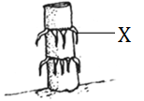40. State the use of roots marked X to the crop below.

_______________________________________________________________________

_______________________________________________________________________

***SECTION B***

41. (a) What are vertebrates?

__________________________________________________________________________________________________________________________________________________________________________________________

(b) Give the reason why some animals are called oviparous.

__________________________________________________________________________________________________________________________________________________________________________________________

(c) Name one example of each of the following;

(i) Reptiles ________________________________________________________________________________

(ii) Amphibians ___________________________________________________________________________

42. (a) Name the dangerous substance found in tobacco.

_____________________________________________________________________________________________

(b) Write down two types of smoking.

(i) __________________________________________________________________________________________

(ii) _________________________________________________________________________________________

(c) State the effect of smoking to a pregnant woman.

__________________________________________________________________________________________________________________________________________________________________________________________

43. ***Match correctly, lists of animals with their respiratory organs***.

**Animals** **Respiratory organ**

Insects Lungs

Fish Spiracles

Spider Gills

Man Book lungs

(i) Fish _________________________________________________________________________

(ii) Spider _________________________________________________________________________

(iii) Man _________________________________________________________________________

(iv) Insects _________________________________________________________________________

44. ***Use the diagram below to answer questions that follow***.

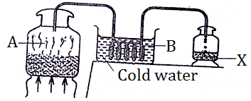

(a) Name the method of making alcohol shown above.

__________________________________________________________________________________________________________________________________________________________________________________________

(b) What scientific name is given to substance X?

_____________________________________________________________________________________________

(c) Name the physical process taking place at

(i) A ________________________________________________________________________________________

(ii) B _______________________________________________________________________________________

45. (a) Write DPT in full as used in the study of human health.

_____________________________________________________________________________________________

(b) Why is DPT vaccine called a triple vaccine?

__________________________________________________________________________________________________________________________________________________________________________________________

(c) Name the organization in Uganda that manages immunization programmes.

_____________________________________________________________________________________________

(d) Identify any one role of family members in promoting immunization programmes.

__________________________________________________________________________________________________________________________________________________________________________________________

46. (a) How does sound travel?

_____________________________________________________________________________________________

(b) Name one group of music instruments.

_____________________________________________________________________________________________

(c) Mention two devices used to store sound.

(i) __________________________________________________________________________________________

(ii) _________________________________________________________________________________________

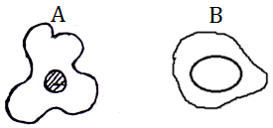47. ***The diagrams below are of blood cells. Use them to answer questions that follow***.

(a) Name the blood cells marked;

(i) A ________________________________________________________________________________________

(ii) B _______________________________________________________________________________________

(b) Identify any one disease that affects blood cells marked B.

_____________________________________________________________________________________________

_____________________________________________________________________________________________

48. (a) Give one example of each of the following types of changes.

(i) Biological changes:

_____________________________________________________________________________________________

(ii) Chemical changes:

_____________________________________________________________________________________________

(iii) Physical changes:

_____________________________________________________________________________________________

(b) Describe any one characteristic of a chemical change.

__________________________________________________________________________________________________________________________________________________________________________________________

**49. Study the table below and carefully fill in the gaps**.

|  |  |  |
| --- | --- | --- |
| **Food stuff** | **Food value** | **Deficiency disease** |
| Meat, liver, spinach |  | Anaemia |
|  | Carbohydrates | Marasmus |
| Beans, meat, eggs | Proteins |  |
| Oranges, lemon, fresh | Vitamin C |  |

50. (a) What is soil/land pollution?

__________________________________________________________________________________________________________________________________________________________________________________________

(b) Give two examples of soil pollutants.

(i) __________________________________________________________________________________________

(ii) _________________________________________________________________________________________

(c) What is the effect of harmful substances on soil?

__________________________________________________________________________________________________________________________________________________________________________________________

51. (a) Apart from water, name any other two materials used for making ORS at home locally.

(i) __________________________________________________________________________________________

(ii) _________________________________________________________________________________________

(b) Why is a person vomiting a lot given ORS to drink?

__________________________________________________________________________________________________________________________________________________________________________________________

(c) Give any one sign of a dehydrated person.

__________________________________________________________________________________________________________________________________________________________________________________________

52. ***The diagram below shows a fish. Use it to answer questions that follow***.

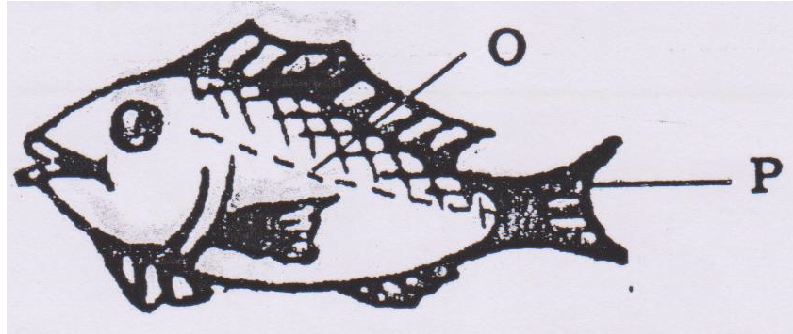

(a) Under which group of vertebrates does the above organism belong?

__________________________________________________________________________________________________________________________________________________________________________________________

(b) Name the part marked P.

_____________________________________________________________________________________________

(c) Of what importance is part O to the organism above?

__________________________________________________________________________________________________________________________________________________________________________________________

(d) Identify the food value obtained from eating the above animal.

_____________________________________________________________________________________________

53. (a) Name any one example of exotic breeds of goats.

_____________________________________________________________________________________________

(b) Give two reasons why farmers rear goats?

(i) __________________________________________________________________________________________

(ii) _________________________________________________________________________________________

(c) Why is spraying necessary in goat management?

__________________________________________________________________________________________________________________________________________________________________________________________

54. (a) Give one example of each of the following;

(i) Disease of the digestive system

_____________________________________________________________________________________________

(ii) Disorders of the digestive system

_____________________________________________________________________________________________

(b) Where does the digestion of food end in man?

_____________________________________________________________________________________________

(c) How can one maintain the efficiency of the digestive system?

__________________________________________________________________________________________________________________________________________________________________________________________

55. (a) What do we call the massive movement of bees from one place to another in search of a new home?

__________________________________________________________________________________________________________________________________________________________________________________________

(b) Identify any two reasons for swarming.

(i) __________________________________________________________________________________________

(ii) _________________________________________________________________________________________

(c) Name any one enemy of bees.

_____________________________________________________________________________________________

***\*\*\*\*\*GOD BLESS\*\*\*\*\****